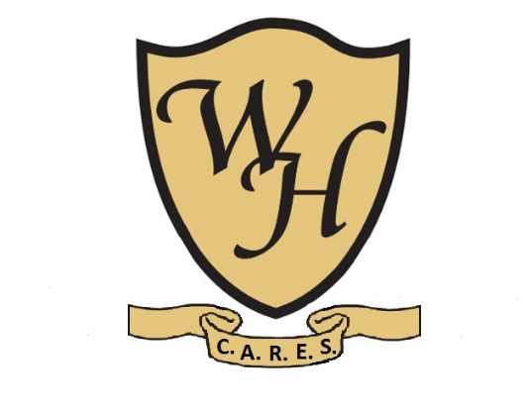
School Uniform Policy 2023-24
At Woolton High School we believe that all students represent the school and as such are the ambassadors of the school whilst on site and in the wider community.
We also believe that our students are influential role models for those around them and as such should be presentable at all times.
All students are in the ongoing process of preparation for employment and as such, school uniform forms an integral part of their learning to embrace “other than personal” preference with regards to the dress code.
As such, we believe that our students’ learning of wearing a school uniform is a part of their learning of essential life skills that may be essentials for their future employability.

Aims
Our aim in having a school uniform for the students is to ensure:
- Clear guidelines are laid down for families and students with regards to the expectations of dress code and presentation during term time activity
- That through such dress code, all students appear smart
- That through a shared school uniform, students share the belonging to the school community and show this when on site or offsite
- That wearing a school uniform helps us safeguard our students when out on community visits
Expectations
- All families will follow specific uniform list and ensure that their child has all of the items of the uniform required
- All families will ensure that their child only wears the items specified and no other items
- All families will ensure that their child is presentable in line with the expectations
- All families will ensure that their child only brings to school items that are permitted at school
- All families struggling to source or execute this policy will seek support from the school
- All students will adhere to the expected standards of uniform and presentation.

Value for money consideration
To ensure our families get the best value for money when purchasing school uniform, Woolton High School have chosen items which can be readily sourced from a variety of suppliers.
Plain items, such as white shirts, black trousers and black blazers can be purchased from local large supermarkets or departmental stores often at a lower cost than school uniform shops.
School uniform
Plain white shirt (long or short sleeved)
Plain black jumper
Black school trousers
Black blazer (if desired)
School tie (available from school, the first tie is available without charge, any purchase thereafter is at the cost of £3)

PE kit

Tracksuit

T-shirt

Shorts

Jogging bottoms

Trainers

Any PE kit must be appropriate to the school setting and must not include language/slogans that could be deemed offensive.

Non-uniform and dress-up days:
- The Headteacher may approve some non-uniform days each year
- Clothes worn on non-uniform days should must be appropriate to the school setting and must not include language/slogans that could be deemed offensive
Nails, Hair and Jewellery:
- Students’ nails should be natural, they should be short and smooth to allow safe physical interactions with tasks and people
- Hair should be either short or if long, tied back during PE/physical activities
- No hats should be worn indoors
- We discourage students’ wearing of jewellery. If jewellery is worn, it must be kept to a minimum, and removed for PE purposes or on instruction of the school staff.
- Piercings are a personal choice, but at school, no facial or tongue jewellery may be worn.
Personal items and liability for loss or damage:
- All uniform items must be clearly labelled with a student’s full name
- Students should not bring valuables into school
- Mobile phones brought into school will be stored in the pupil’s individual locker
- The school is not liable for loss or damage to any item of uniform or personal possessions brought into school by the students

Policy agreed November 2023
To be reviewed: September 2024

